The Rock
Søknadsskjema / Application form
Send to mail: kontakt@ekergaard.no

Navn / Name
Fornavn / First name ____________________________________________
Etternavn / Surname ____________________________________________
E-post / Email ____________________________________________
Adresse / Address ____________________________________________
Gateadresse / Street address ____________________________________________
By / City ____________________________________________
State / Province / Region ____________________________________________
Postnummer / Zip code ____________________________________________
Land / Country ____________________________________________

Fødselsdato / Date of birth __________________________________dd/mm/yyyy

Nettside / Website https://______________________________________

Ønsket periode / Residency period of choice
Spring 2022 (2 May – 15 June) Preferred : ________________
Summer/fall 2022 (1 August – 1 November) Preferred: ________________
Winter 2022/3 ( 1 December – 1 April) Preferred : ________________
Spring 2023 (2 May – 15 June) Preferred : ________________
Summer/fall 2023 (1 August – 1 November) Preferred: ________________
Winter 2023/4 ( 1 December – 1 April) Preferred : ________________

Mandatory attachments
1 - Søknadstekst / Application text
Beskriv motivasjonen og planene dine for oppholdet / Describe your motivation and plans for the residency (max. 2000 characters).
2 - Krav til utstyr og atelier/ Requirements for equipment and studio
3 - CV
4 – Dersom din webside ikke inneholder presentasjon av tidligere arbeider må dette vedlegges / If your website does not contain documentation of previous work, this must be attached.

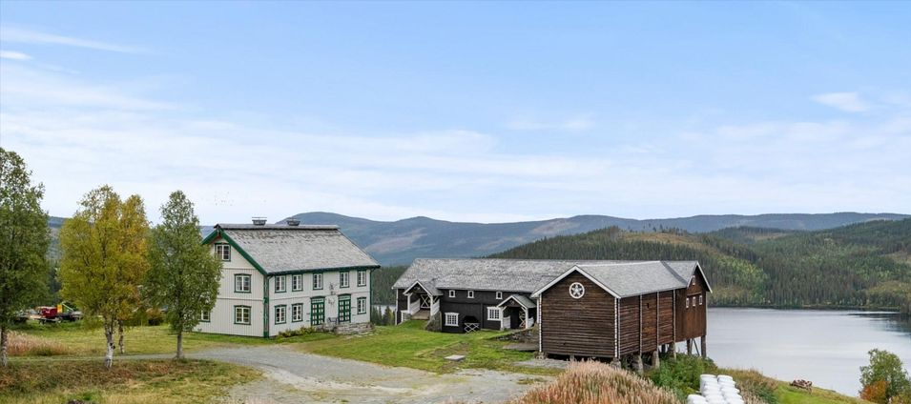

Description
The ROCK artist's residence is located on the beautiful 18th century yard in Skammestein and is run by sculptor Anni Onsager and Eker Gård culture and nature. The farm consists of a professional gallery that shows well-known artists, a barn with the possibility of concerts, parties, courses and studios and a permaculture garden that develops in collaboration with the organization Kvann.
Anni Onsager, owner and operator Eker Gård, is educated in England with a master's degree in sculpture. Sigmund Bakken is a co-driver of the gallery has extensive experience with gallery operations.
The Artist in Residents program will be searchable for Norwegian and foreign artists. The artists intend to stay on site for 1-6 weeks and use the surroundings in Øystre Slidre as inspiration for their own art production. After the stay, we will hava a exhibit in the main gallery or in a special and suitable location in and around the farm.
The name
The name The Rock is linked to the place name Skammestein, stein in Norwegian means rock. Just above the farm towers the mountain with one of Valdres mountain flags and on the field outside is a stone with history from the previous ice age.
Jotunheimen, which is a few km from the farm, is one of Norway's most beautiful and wild mountain areas. Beitostølen nearby has for many years the house and music festival called Troll Rock and the driver of the residency program is a sculptor, also with stone as material.
Housing and studio
The artists live in a small cabin or in the main house with its own room and private bathroom (shared bathroom if there are several) they have access to their own kitchen or outdoor kitchen and can use the farm's facilities. There are several rooms available for studio space.
We will help visiting artists to experience the area's nature and culture and help with equipment and give other necessary support.
Targetgroup
The target group is all professional artists. Natural choices are artists who want to be inspired by nature and preferably in combination with green values, ecology, nature relations and climate issues. It can be visual artists in all disciplines and musicians, writers and performance.
Selection of artists
The applications will be evaluated by Anni Onsager, Sigmund Bakken and 1-2 experts in the artistic field applied for. In interdisciplinary applications, more than one evaluator of different art fields can evaluate the application. We plan to adapt application deadlines so that grants can be applied for from available funds, at least for Norwegian artists. The processing of applications is based on professional assessment and whether we can offer what is desired by the artist. In addition, we want the artist to use the fantastic surroundings both on the farm and in the region, and also Valdres culture as inspiration for his work when they are here. But we do not want to set too strict limits and want artists in Visual Arts. - Audiovisual art - Literature - Music - Performing arts welcome to apply.
Time period
A stay can be adapted to the artist's wishes both in time and length, but must be a minimum of 1 and a maximum of 6 weeks.
Transportation
You can bring your own car, rent a car from the airport or take a bus that goes many times a day to Oslo and several other places via Fagernes. We can pick up at the bus stop but it is also possible to walk. We want bikes available.
Subsidies for accommodation and materials
We are working to get a grant but unfortunately can not currently guarantee financial assistance.
Prices for 2022
(per person):
Price per stay 100 EUR ex food
Prices include bed linen, towels, access to washing machine, kitchen, private bathroom, wifi.
The location
The farm is called Eker farm. It is beautifully and sunnyly located in the village Skammestein in Øystre Slidre municipality, north of Valdres with a wide view over the valley, to Hedalsfjorden and the surrounding mountains. Located approx. 700 m.o.h in Bygdinvegen 3150, 2950 Skammestein.
The farm is located about 6 km from Beitostølen and 32 km north of Fagernes, right by county road 51.
The buildings are from the 18th century. The main house has 120 m2 gallery on the ground floor and has 6 bedrooms and 4 bathrooms. The barn is approx. 740 m2 with 2 floors. The barn has various rooms that can be used for studios.
The area is located between two national parks, Jotunheimen and Langsua. Jotunheimen is a mountain area in central southern Norway between Ottadalen in the north, Gudbrandsdalen in the east, Valdres in the south and Sogn in the west. Here are the highest mountains in Northern Europe, Galdhøpiggen and Glittertinden. A little south is Langsua with an extensive family-friendly landscape. Here, lush birch forests, old exciting coniferous forests meet,
rolling mountain ranges, beautiful watercourses with fine trout and diverse wetlands. The peaks and Langsua offer magnificent views.
The program
Our program is intended to be adapted to fit each artist in residence. We will try to connect with other artists locally / regionally who work in the same field and invite to workshops and lectures that may also be available to other art enthusiasts. Anni Onsager and Sigmund Bakken will be available for conversations on the desired topic and the farm staff will help with any questions the artist may have.
We will take the artists on a tour to experience nature in the area and to climb mountains either on skis or on foot. Everyone gets the opportunity if they want to climb Synshorn via the mountainside by rope, the back by foot or on skis with randonee in the winter. We will visit Valdres Museum for inspiration from local cultural heritage and if possible take the artist to concerts and events that are found locally during the work period.
The goal is for the works that are developed to have inspiration from the area and thus take it further in their artistic work. It will be able to build good stories about the region and create awareness of the place.
As far as possible, we will seek to provide the desired project guidance and criticism. The artist will have 24-hour access to a studio tailored to their needs and some tools. They have private bedrooms and bathrooms, can use indoor and outdoor common / shared rooms, enjoy homemade meals and locally grown vegetables (seasonal). Materials and supplies for project production are not included, but can be purchased locally if possible.
Application
We want applications from Norwegian and international professional artists who are members of an artists' organization and who work in one of these fields: visual art, textiles, sculpture, digital art, country art, crafts, writing, curation and music.
We can help provide the necessary materials and equipment, but it is basically intended that this is brought along. List of available equipment will be available soon.
The artists will be offered to exhibit in the main gallery or a suitable place in the yard and will give a lecture, readings, mini-concert or a presentation of the work from the stay and their art for visitors / guests to the farm.

Contact
Contact mail for more information: kontakt@ekergaard.no

